e-KMTC GUIDE

Contents e-KMTC GUIDE

1. Benefit and advantage of using e-KMTC
2. WEB Address
3. Registration
4. Login
5. Schedule
6. Speed Inquiry
7. Export
1) Booking
2) Shipping Instruction
3) B/L Inquiry
8.Cargo Tracking
10. My Menu
11. My Page

- 1 –
Benefit and advantage e-KMTC GUIDE

KMTC line is pleased to introduce e-KMTC which helps our customers to do business with us more easily and more efficiently.

Through e-KMTC, you can find real-time information such as schedule, cargo tracking, booking records, B/L records and so on.
You can also use features for booking and B/L with ease.
Therefore, e-KMTC can save you from having to contact us by phone or e-mail, which assists you to manage your time.
KMTC line promises to give feedbacks upon your WEB request in time.

Please register your WEB ID and enjoy e-KMTC.

- 2 -
WEB Address e-KMTC GUIDE

WEB address for e-KMTC is www.ekmtc.com
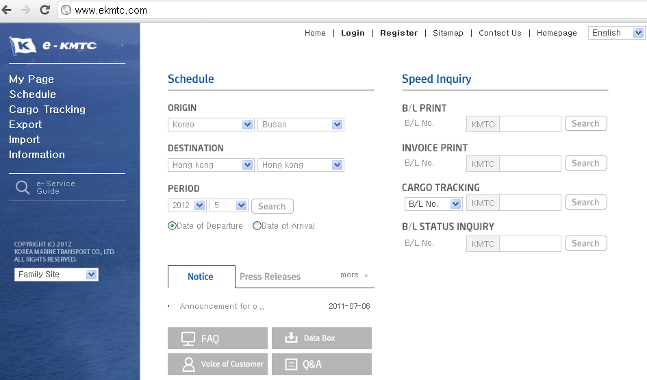

For your reference, our corporate homepage is www.kmtc.co.kr where you can find information about KMTC line.
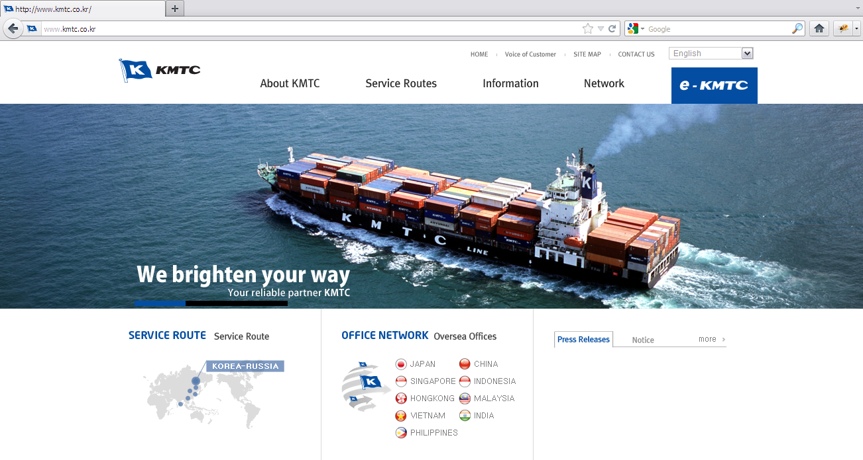
- 3 -
Registration e-KMTC GUIDE

To make full use of e-KMTC, you are recommended to register a WEB ID.

1. After accessing to e-KMTC, please select ‘ENGLISH’ for LANGUAGE if it shows another language.

2. Please click the ‘REGISTER’ to make a new ID.

3. Then, please fill in the form and save.
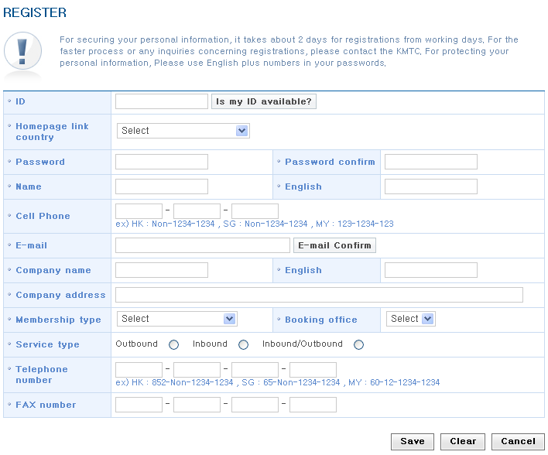

4. Registration needs to be approved by KMTC line. If you contact our local customer service team, it would be done more quickly.

- 4 –
Login e-KMTC GUIDE

To make full use of e-KMTC such as creating booking and shipping instruction, you need to login.
However, for some features such as cargo tracking and B/L status inquiry, you can find information without login.

1. After accessing to e-KMTC, please click ‘Login’, and insert your ID and password.
Also, please make sure to choose ‘Customer’.
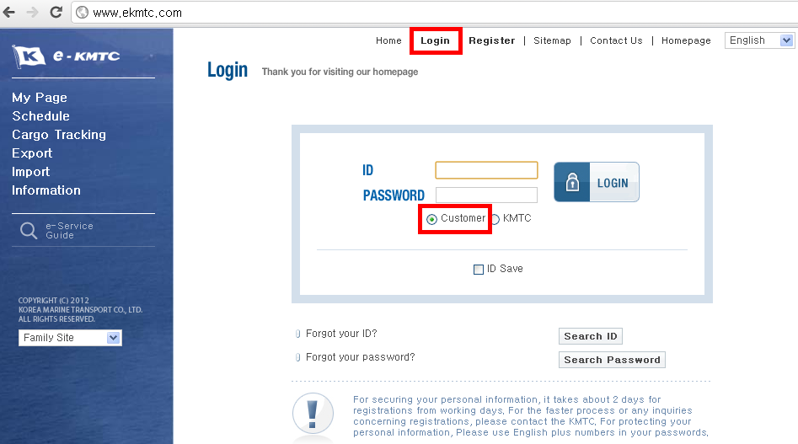

2. If you forget your password, please contact our local customer service team.

- 5 –
Schedule e-KMTC GUIDE

There are a few ways to check schedule.

1. You can find schedule in the main front page.
1) Please choose country and port of origin and destination, and click ‘Search’.
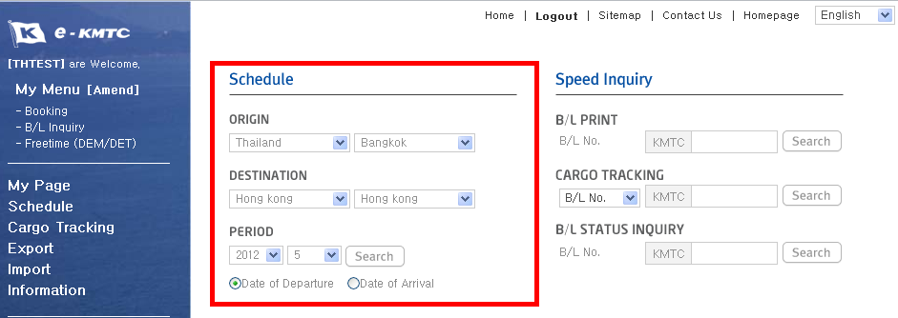

2) Then, vessels are shown on calendar.
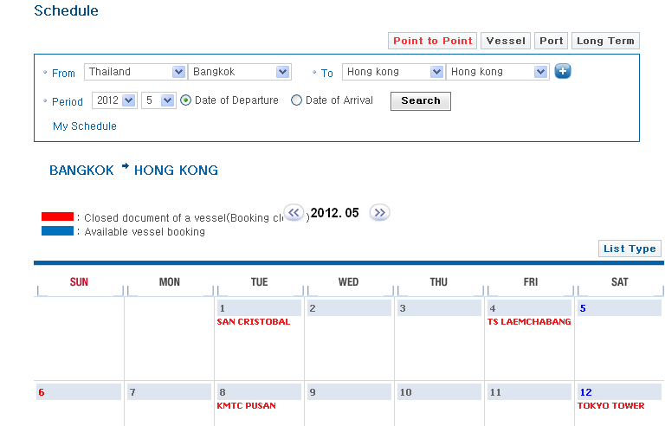
- 6 –
Schedule e-KMTC GUIDE

2. You can find schedule from menu bar.
1) Please click ‘Schedule’ and choose one of ‘Point to Point’, ‘Vessel’, ‘Port’ and ‘Long Term’.
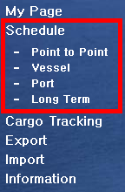
2) If you choose ‘Point to Point’, please select country and port of origin and destination.
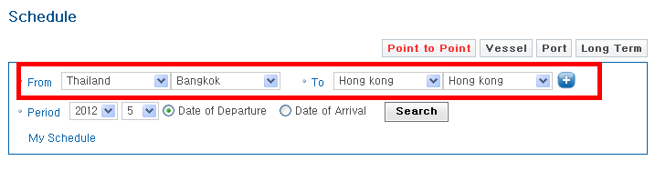
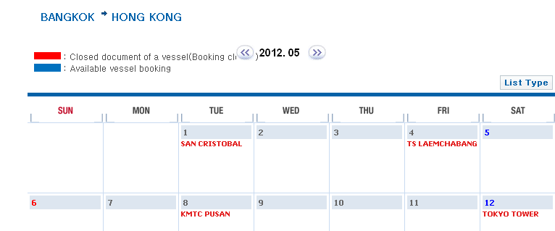

- 7 –
Schedule e-KMTC GUIDE

3) If you choose ‘Vessel’, please search for vessel name and input voyage.
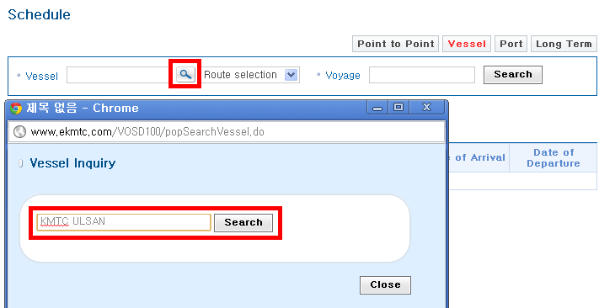

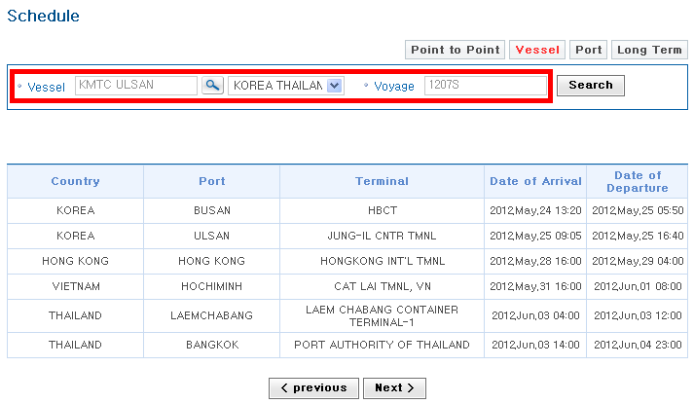

- 8 –
Schedule e-KMTC GUIDE

4) If you choose ‘Port’, please select country and port, and set period.
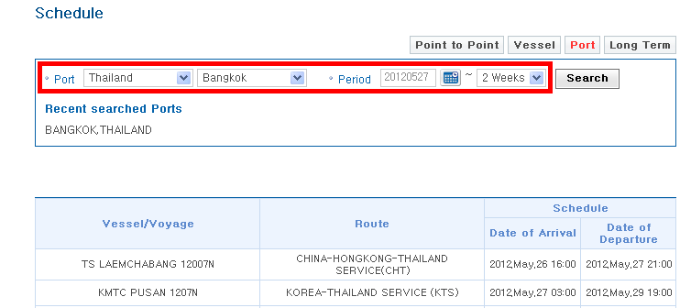

5) If you choose ‘Long Term’, please select country and port of origin and destination, and set period.
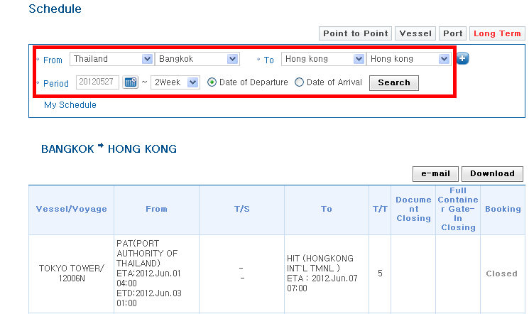

- 9 –
Speed Inquiry e-KMTC GUIDE

In the main front page, you can print off B/L copy and invoice. You can also search for cargo location and if B/L has been issued or not.
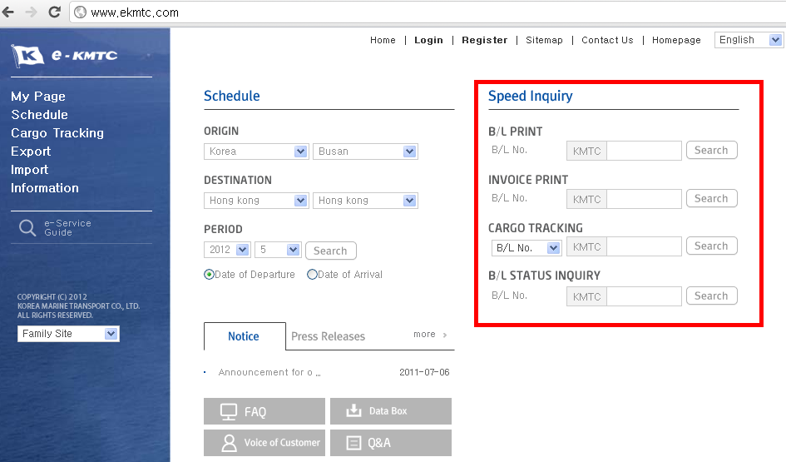

1. B/L Print: you can print off B/L copy, Seaway Bill, or Surrendered B/L.
2. Invoice print: you can print off an invoice.
* This menu might not be available in some countries.
3. Cargo Tracking: you can find the location of your cargo.
4. B/L Status Inquiry: you can find if a B/L has been issued or not.

- 10 –
Export – Booking e-KMTC GUIDE

There are three ways to create a new booking request.

1. After finding schedule.
1) Please find schedule.
2) Among the displayed vessel on the calendar, you can make a booking on blue-coloured vessel only. Red-coloured one is closed because it has departed or it has no space.
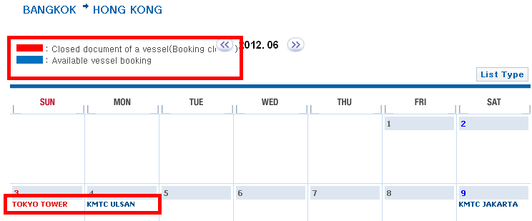
3) If you click a vessel, you can find more detailed schedule below.
4) If you decide to make a booking on the selected vessel, please click the ‘Booking’ at the bottom right-handed side.
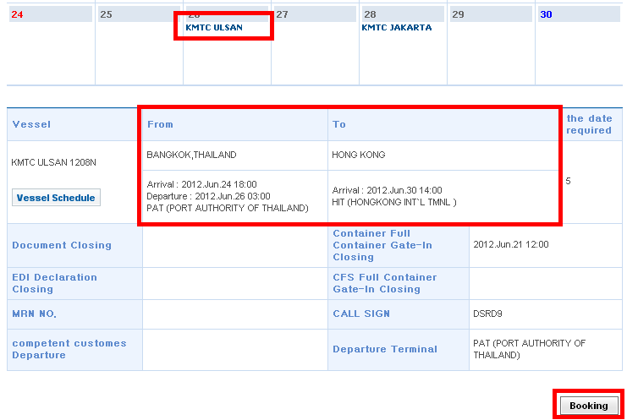
- 11 –
Export – Booking e-KMTC GUIDE

5) Then, you are moved to ‘Booking Master’ where you input more details of your shipment.
6) Please make sure to leave correct contact point. The default is WEB ID information, but you can input directly, or choose from the list.
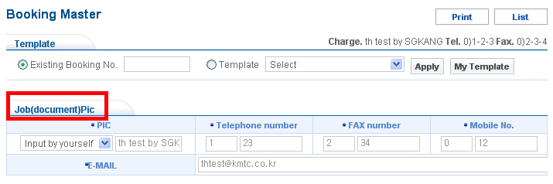
7) Please input a name of B/L Shipper.
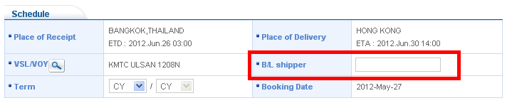
8) Please input container’s size, type, and quantity. If you want to add another size or type of container, please click the ‘+’. Then, please choose pick-up date.
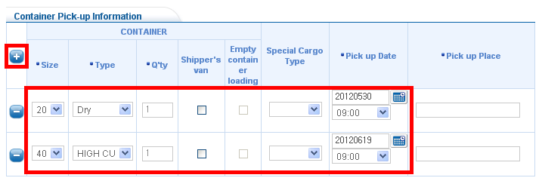

- 12 –
Export – Booking e-KMTC GUIDE

9) If you have any more details of your shipment such as weight, commodity, or request, please leave them in ‘Request Detail’.
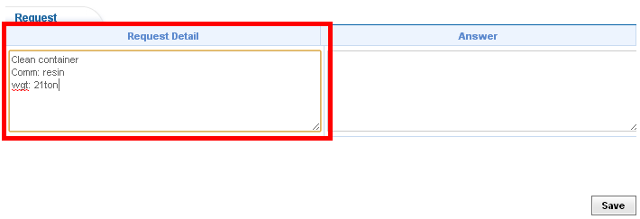
10) In case of dangerous cargo, please choose ‘DG Cargo’ at the ‘Special Cargo Type’. Then, please search for UNNO, and fill in the blanks. All information is inevitable for KMTC to determine to accept the dangerous goods or not. You can upload files such as MSDS, and find KMTC line’s feedback.
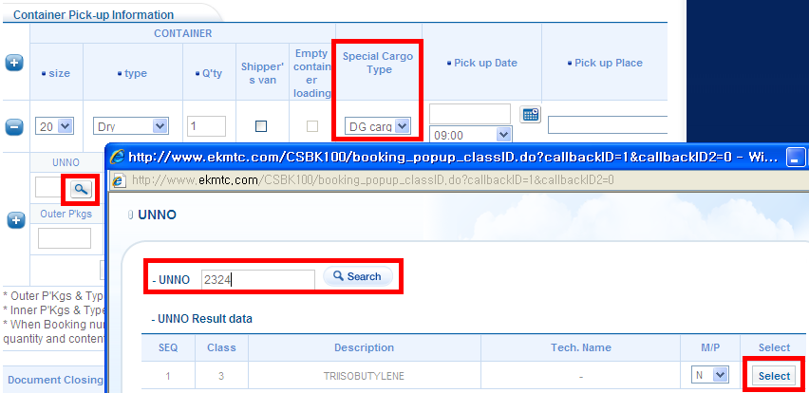
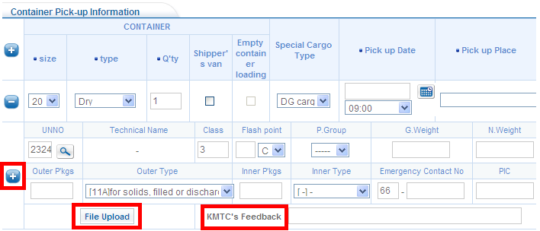
- 13 –
Export – Booking e-KMTC GUIDE

11) For reefer container, please select ‘REEFER’ or ‘REEFER HIGH’ from ‘Type’. Then, please input the number of temperature and ventilation.
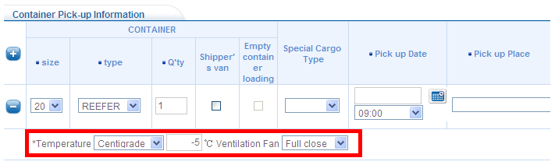
12) If a container type is OPEN TOP, FLAT RACK, or SUPER RACK, please choose (OOG)Out of Gauge’ or ‘In Gauge’ at the ‘Special Cargo.
In case of ‘(OOG)Out of Gauge’, please input measurement and weight.
You can upload files such as photos, and find KMTC line’s feedback.
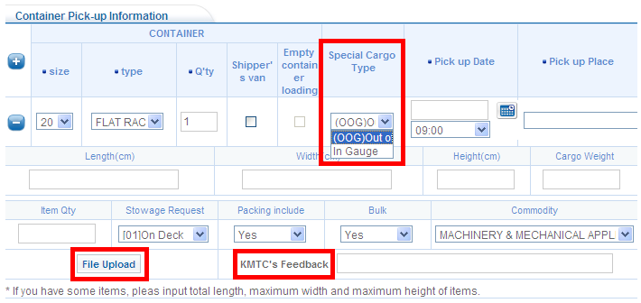
13) After inputting B/L shipper, container information, and request detail, please click ‘Save’ at the bottom right-handed side. Then, a booking number will be given.
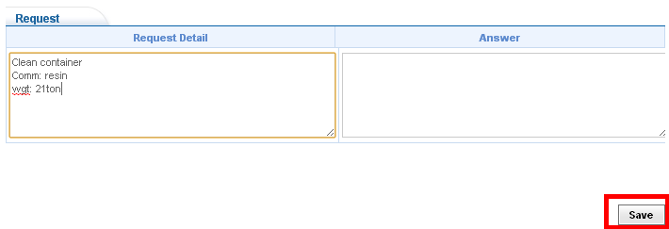
- 14 –
Export – Booking e-KMTC GUIDE

2. Using another booking number. (= booking copy)
1) Please go to ‘Booking’ menu under ‘Export’.
if you know a booking number which you want to make a copy, please move to ‘Booking Master’ by clicking ‘Booking’ at the bottom without searching for booking records.
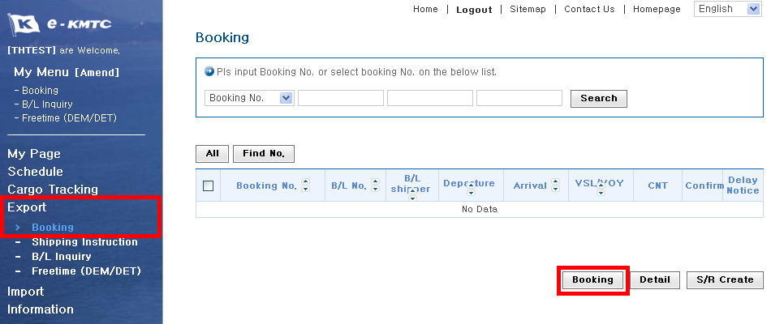

2) Then, please input the booking number in the ‘Existing booking number’, and click ‘Apply’.
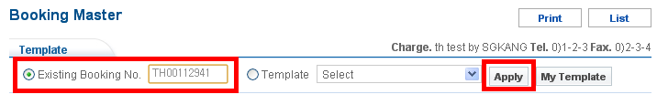

3) If you want to create a new booking on the same vessel, click Yes. Otherwise, please click No.
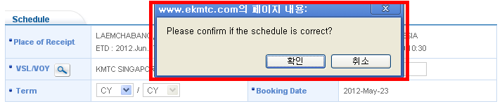

- 15 –
Export – Booking e-KMTC GUIDE

4) Then, you can find data are copied from the booking number. Please choose pick-up date and change other information. Then, click ‘Save’ to get a new booking number.

5) If you don’t know a booking number which you want to make a copy, you can find it in the ‘Booking’ menu under ‘Export’.
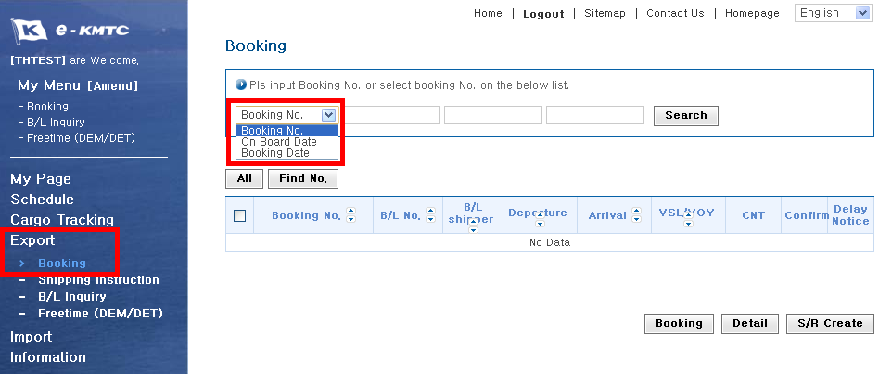

6) After searching for booking records, please choose a booking which you want to make a copy, and click ‘Booking’ at the bottom. Then, other processes are the same.
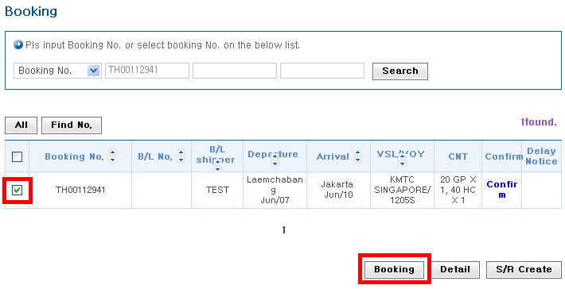
- 16 –
Export – Booking e-KMTC GUIDE

3. Using template file. (= booking copy)
1) After saving a new booking, if you want to use the data as template file, please click ‘Template save’ at the bottom.
Then, please input title and remark for your own reference. And click ‘OK’
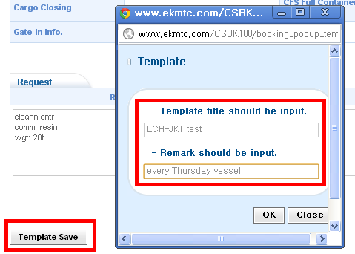

2) In the blank form of ‘Booking Master’, please choose ‘Template’ and select a template file which you want to apply. Then, click ‘Apply’ to get data from the template.
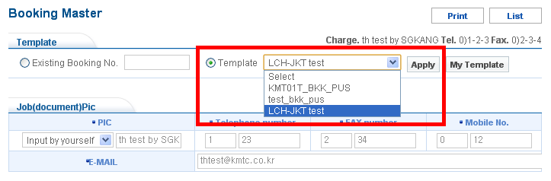

- 17 –
Export – Booking e-KMTC GUIDE

3) Then, except schedule other information is copied.
Please click to find a new vessel.
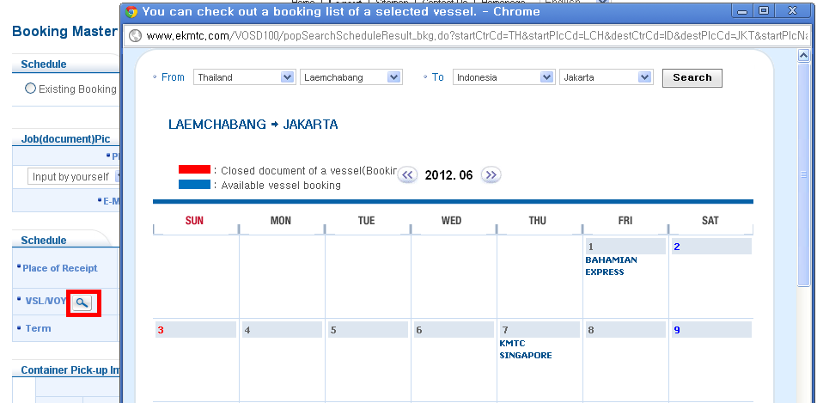

4) Please choose a vessel, and click ‘Booking’. Then, please input pick-up date and change other information. Then, click ‘Save’ to get a new booking number.
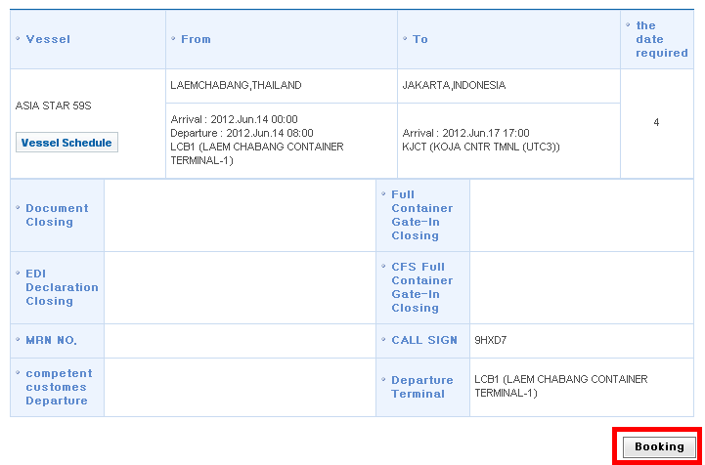
- 18 –
Export – Booking e-KMTC GUIDE

Your web booking request allows us the chance to review your request against other factors such as vessel allocation and equipment availability.
We promise to give feedback to you in time.
You can check if your web booking request is accepted or not in the ‘Booking’ menu under ‘Export’
If it is not yet accepted, ‘Unconfirmed’ in red is shown in ‘Confirm’ column. If it is accepted, ‘Confirm’ in blue is shown.
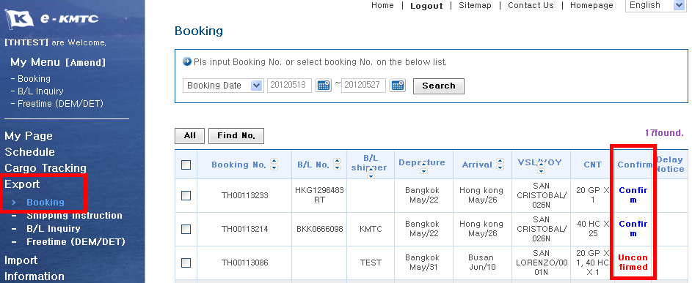

Unconfirmed booking could be revised. If you want to revise it, click the booking number and go to ‘Booking Master’.
However, confirmed booking could not be changed on the WEB. In that case, please contact our local customer service team.

You can also find booking records in the ‘Booking’ menu under ‘Export’.

- 19 –
Export–Shipping Instruction e-KMTC GUIDE

You can input shipping instruction for a B/L. It is easy to make it, and you can print out a B/L copy right away.

1. Please find a booking number either at ‘Booking’ menu or ‘Shipping Instruction’ under ‘Export’, click ‘Create’.
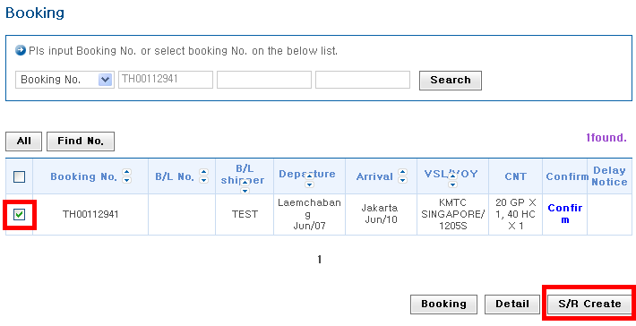
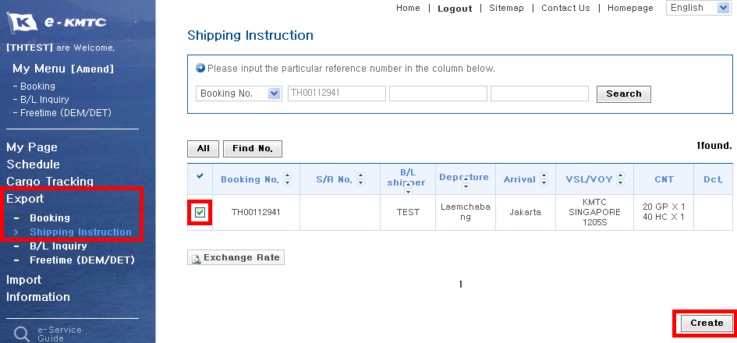

- 20 –
Export–Shipping Instruction e-KMTC GUIDE

2. Then, please input details such as Shipper, Consignee, gross weight, number and type of package, cargo description, and so on. However, please be advised that you don’t need to input every details. You can confirm a shipping instruction first, and then you can amend it in the ‘B/L Inquiry’ menu.
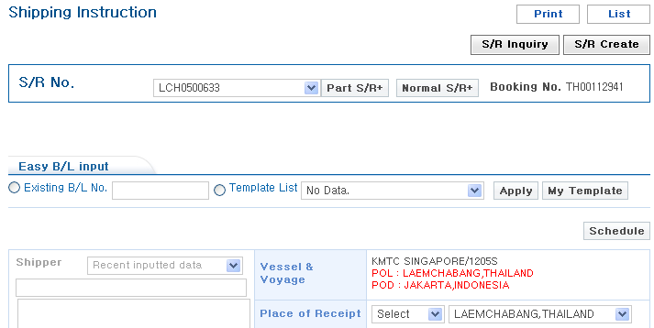

3. You can get data from recent B/L records by ‘Recent inputted data’
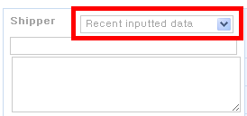

4. If you want to input the same B/L data as one specific number, please input the number in the ‘Existing B/L No.’ and click ‘Apply’. It’s the same feature as booking copy.
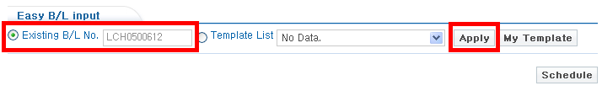
- 21 –
Export–Shipping Instruction e-KMTC GUIDE

5. After inputting some of details, please click ‘Save’ and ‘Confirm’.

6. You can save the data as a template file like a booking template.
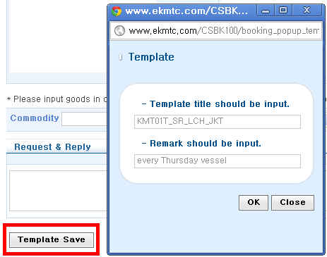

7. After you click ‘Confirm’, please go to ‘B/L Inquiry’ under ‘Export’ if you want to amend some details.

8. If you want to split B/L up into two or more under the same booking number, please click ‘Part S/R +’ or ‘Normal S/R +’.
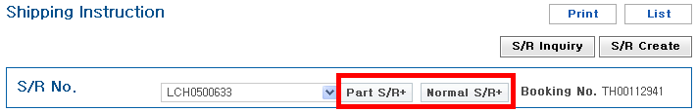
- 22 –
Export–Shipping Instruction e-KMTC GUIDE

9. You can leave requests such as ‘Seaway Bill issue’, ‘O.B/L issue’ in the request detail.
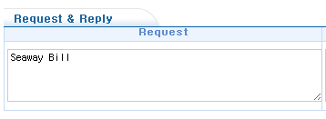

10. If a B/L number is created before you create a shipping instruction, you cannot make a new shipping instruction, but you can amend the B/L data in the ‘B/L Inquiry’.
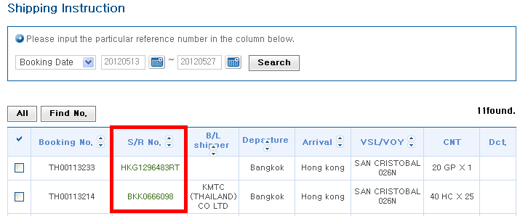

- 23 –
Export – B/L Inquiry e-KMTC GUIDE

You can find B/L records for export in the ‘B/L Inquiry’ under ‘Export’. You can print off a B/L copy or invoice here. And you can amend B/L details by clicking a B/L number.

1. You can search for B/L records.
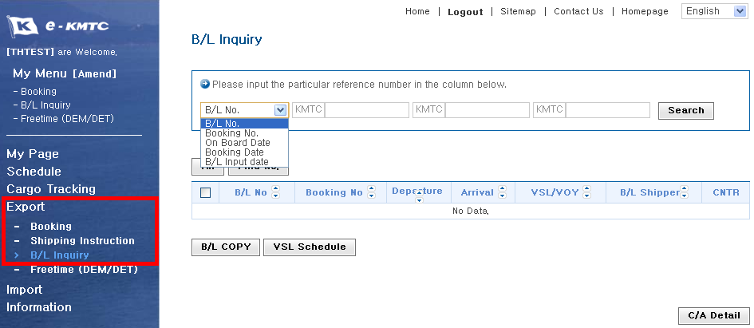

2. If you want to amend B/L details, please click a B/L number.
Then, you will find the term and conditions. If you click ‘Confirm’, you are moving to the ‘B/L Inquiry;.
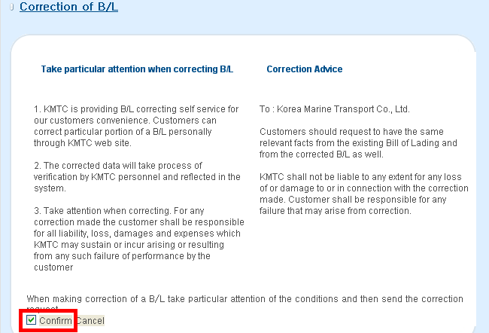
- 24 –
Export – B/L Inquiry e-KMTC GUIDE

3. After changing or updating B/L detail, please click ‘Save’.
KMTC line will check your amendment request, and decide to accept or not.
After we accept it, it will be reflected on the B/L.

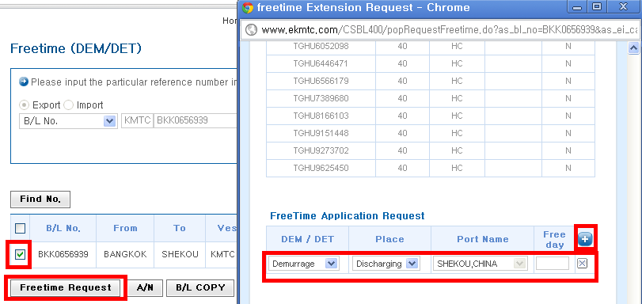

3. If you click ‘Free Time Tariff’, you can find the information of other ports.
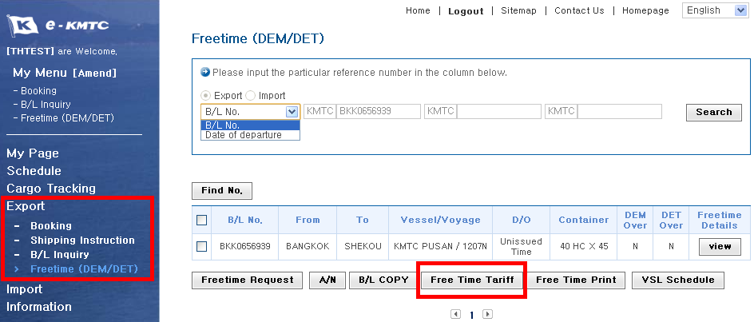

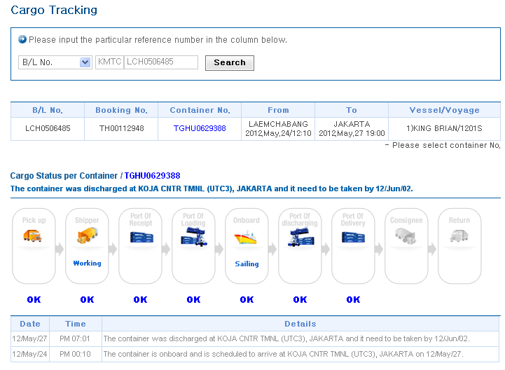

- 31 –
My Menu e-KMTC GUIDE

You can make a kind of shortcut for each menu in the My Menu.
If you add frequently used menu under ‘My Menu’, it would be helpful for you to access the menu quickly.

1. Please click [Amend].
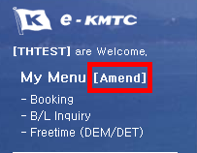

2. Please select menu which you want to add under your ‘My Menu’, and click ‘Save’.
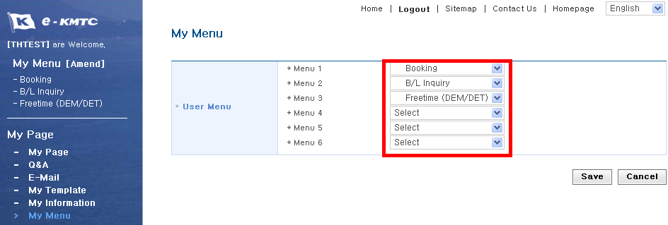

3. Then, you can find them under ‘My Menu’.

- 32 –
My Page e-KMTC GUIDE

You can find information related to you in the ‘My Page’

1. You can find your booking and B/L records in the ‘My Page’.
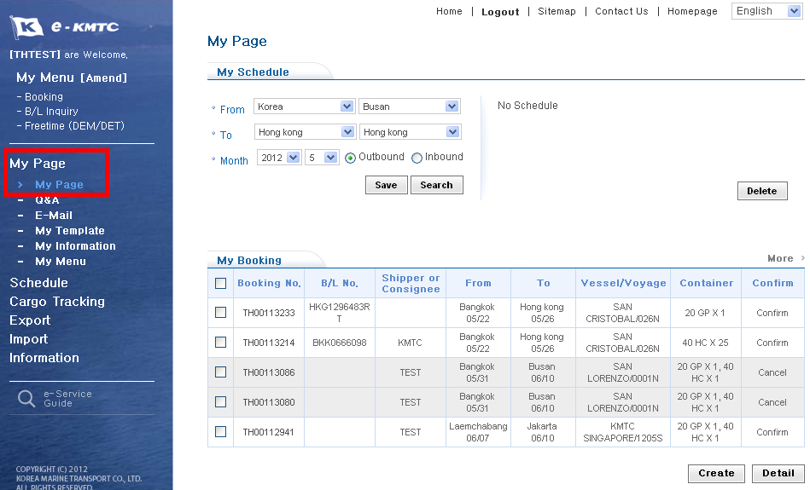

2. You can also manage your booking and S/R template in the ‘My Template’. You can make a new booking or S/R using the template file.
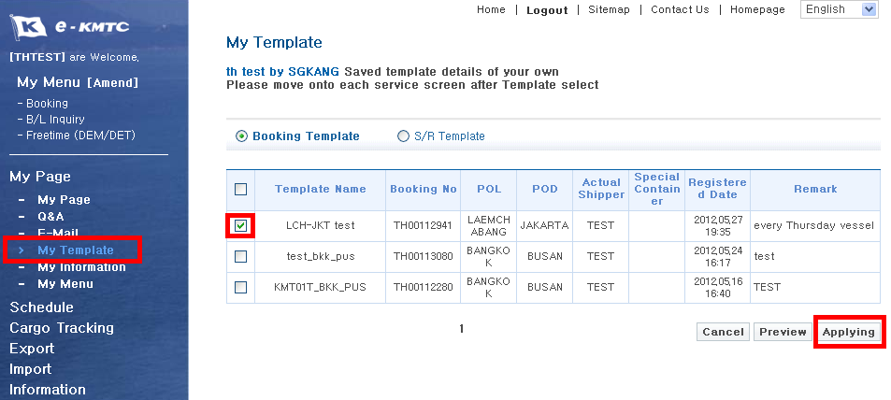
- 33 –
My Page e-KMTC GUIDE

3. You can change the WEB ID information in the ‘My Information’.
